**Lab No 8**

**Name : Muhammad Faizan Reg. No. : 21-NTU-CS-1258**

**(Q1)**

#include<iostream>

using namespace std;

int main()

{

int ar1[5];

ar1[0]=1;

ar1[1]=2;

ar1[2]=3;

ar1[3]=4;

ar1[4]=5;

cout<<"The elements of array are the following\n";

cout<<ar1[0]<<endl;

cout<<ar1[1]<<endl;

cout<<ar1[2]<<endl;

cout<<ar1[3]<<endl;

cout<<ar1[4]<<endl;

}**Output**

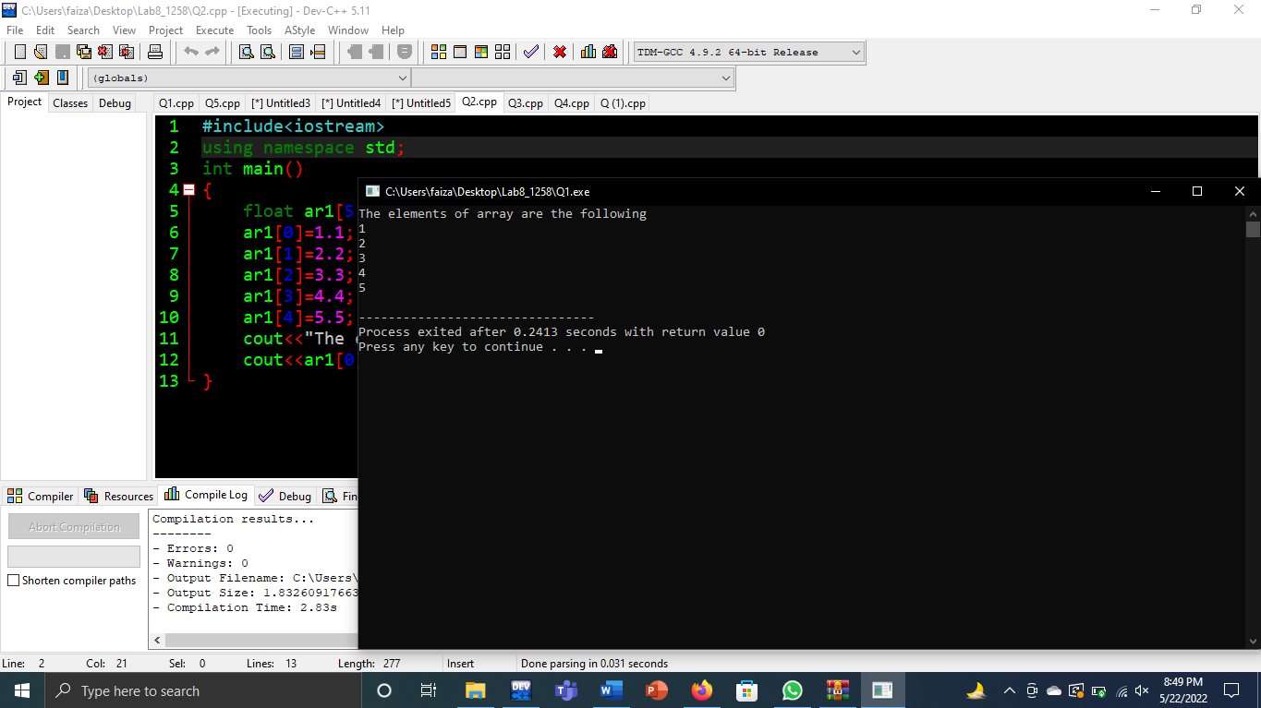

**(Q2)**

#include<iostream>

using namespace std;

int main()

{

float ar1[5];

ar1[0]=1.1;

ar1[1]=2.2;

ar1[2]=3.3;

ar1[3]=4.4;

ar1[4]=5.5;

cout<<"The elements of array are the following\n";

cout<<ar1[0]<<"\t"<<ar1[1]<<"\t"<<ar1[2]<<"\t"<<ar1[3]<<"\t"<<ar1[4]<<endl;

}

**Output**

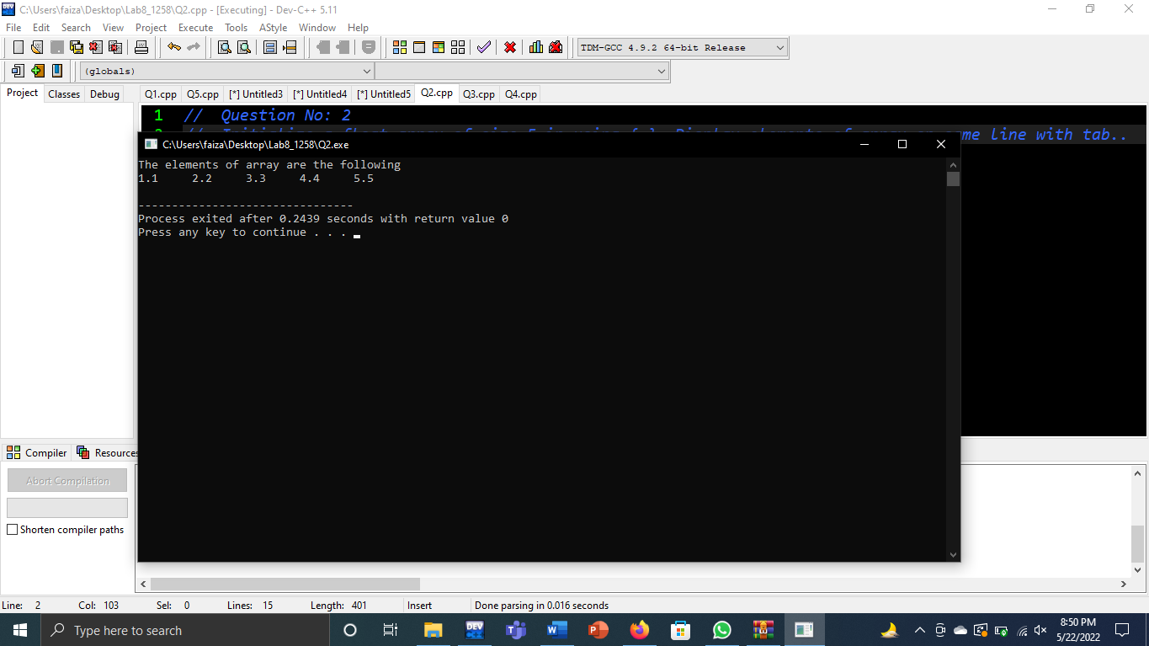

**(Q3)**

#include<iostream>

using namespace std;

int main()

{

int ar1[5],avg,sum;

cout<<"Enter the marks of first student ";

cin>>ar1[0];

cout<<"Enter the marks of second student ";

cin>>ar1[1];

cout<<"Enter the marks of third student ";

cin>>ar1[2];

cout<<"Enter the marks of fourth student ";

cin>>ar1[3];

cout<<"Enter the marks of fifth student ";

cin>>ar1[4];

sum=ar1[0]+ar1[1]+ar1[2]+ar1[3]+ar1[4];

avg=sum/5;

cout<<"\nThe average marks of students is "<<avg;

}

**Output**

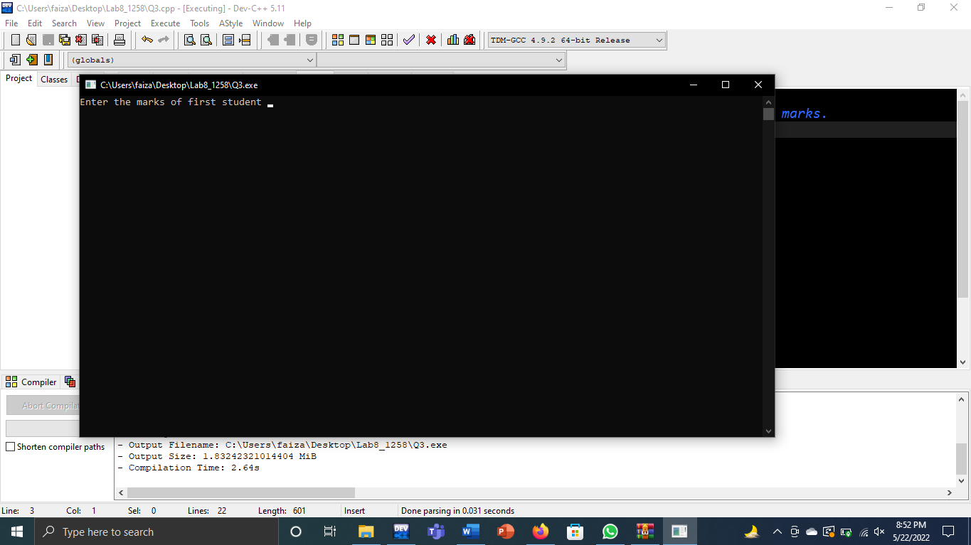

**(Q4)**

#include<iostream>

using namespace std;

int main()

{

int num[7];

cout<<"Enter Marks of Student # 1 : ";

cin>>num[0];

cout<<"Enter Marks of Student # 2 : ";

cin>>num[1];

cout<<"Enter Marks of Student # 3 : ";

cin>>num[2];

cout<<"Enter Marks of Student # 4 : ";

cin>>num[3];

cout<<"Enter Marks of Student # 5 : ";

cin>>num[4];

num[5]=num[6]=num[0];

// For Maximum Marks & num[5]=min

(num[5]<num[1])? num[5]=num[1]:num[5]=num[5];

(num[5]<num[2])? num[5]=num[2]:num[5]=num[5];

(num[5]<num[3])? num[5]=num[3]:num[5]=num[5];

(num[5]<num[4])? num[5]=num[4]:num[5]=num[5];

cout<<"\nMaximum Marks are : "<<num[5];

// For Minimum Marks & num[6]=max

(num[6]>num[1])? num[6]=num[1]:num[6]=num[6];

(num[6]>num[2])? num[6]=num[2]:num[6]=num[6];

(num[6]>num[3])? num[6]=num[3]:num[6]=num[6];

(num[6]>num[4])? num[6]=num[4]:num[6]=num[6];

cout<<"\nMinimum Marks are : "<<num[6];

}

**Output**

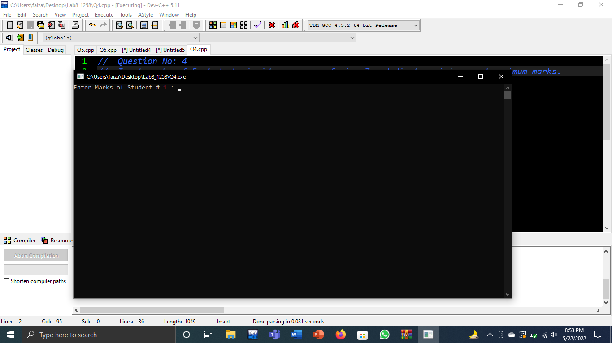

**(Q5)**

#include<iostream>

using namespace std;

int main()

{

char ar1[5]= {'1','2','3','4','5'};

char ar2[5];

cout<<"Enter Character # 1 : ";

cin>>ar2[0];

cout<<"Enter Character # 1 : ";

cin>>ar2[1];

cout<<"Enter Character # 1 : ";

cin>>ar2[2];

cout<<"Enter Character # 1 : ";

cin>>ar2[3];

cout<<"Enter Character # 1 : ";

cin>>ar2[4];

cout<<"\nArray 1 with constants : "<<ar1[0]<<ar1[1]<<ar1[2]<<ar1[3]<<ar1[4];

cout<<"\nArray 2 with User Input : "<<ar2[0]<<ar2[1]<<ar2[2]<<ar2[3]<<ar2[4];

}

**Output**

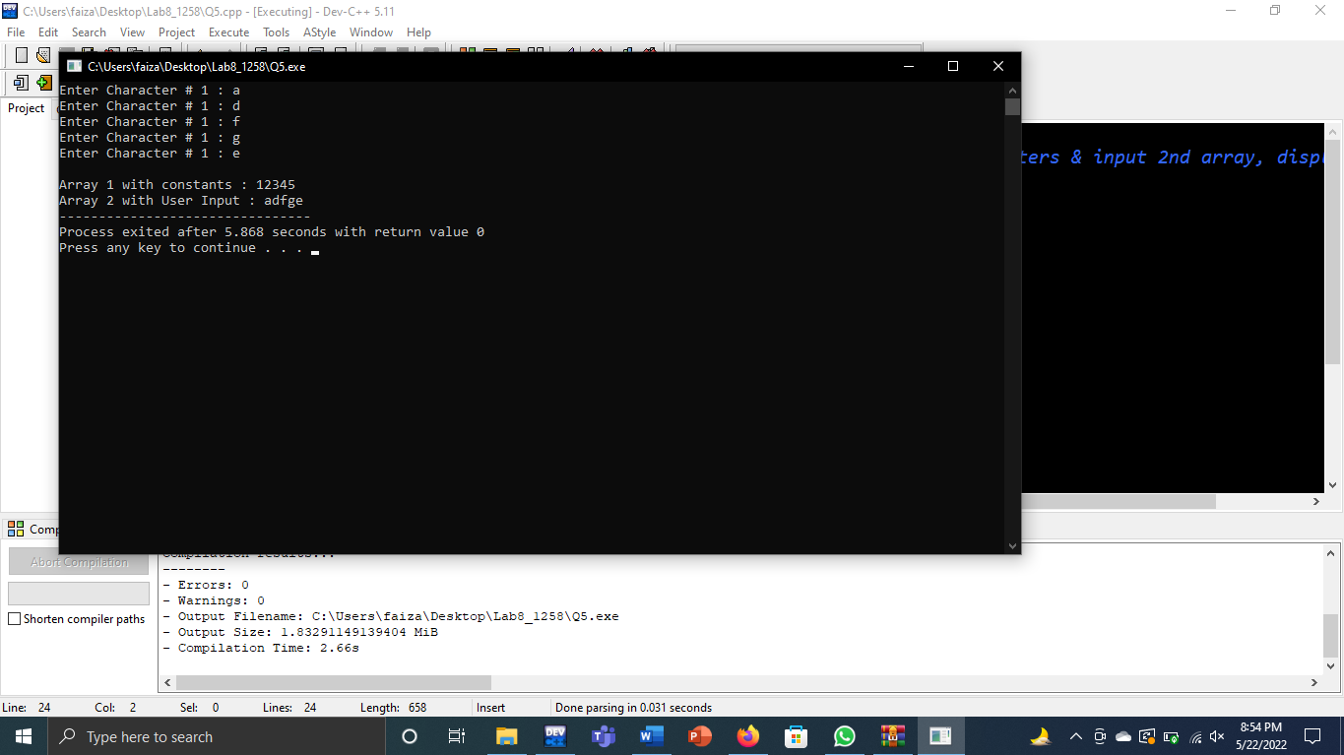

**(Q6)**

#include<iostream>

using namespace std;

int main()

{

float ar1[5],ar2[5];

cout<<"Enter Float Value # 1 : ";

cin>>ar1[0];

cout<<"Enter Float Value # 2 : ";

cin>>ar1[1];

cout<<"Enter Float Value # 3 : ";

cin>>ar1[2];

cout<<"Enter Float Value # 4 : ";

cin>>ar1[3];

cout<<"Enter Float Value # 5 : ";

cin>>ar1[4];

ar2[0]=ar1[0],ar2[1]=ar1[1],ar2[2]=ar1[2],ar2[3]=ar1[3],ar2[4]=ar1[4];

cout<<"\nArray 2 with User Input : ";

cout<<ar2[0]<<" "<<ar2[1]<<" "<<ar2[2]<<" "<<ar2[3]<<" "<<ar2[4];

}

**Output**

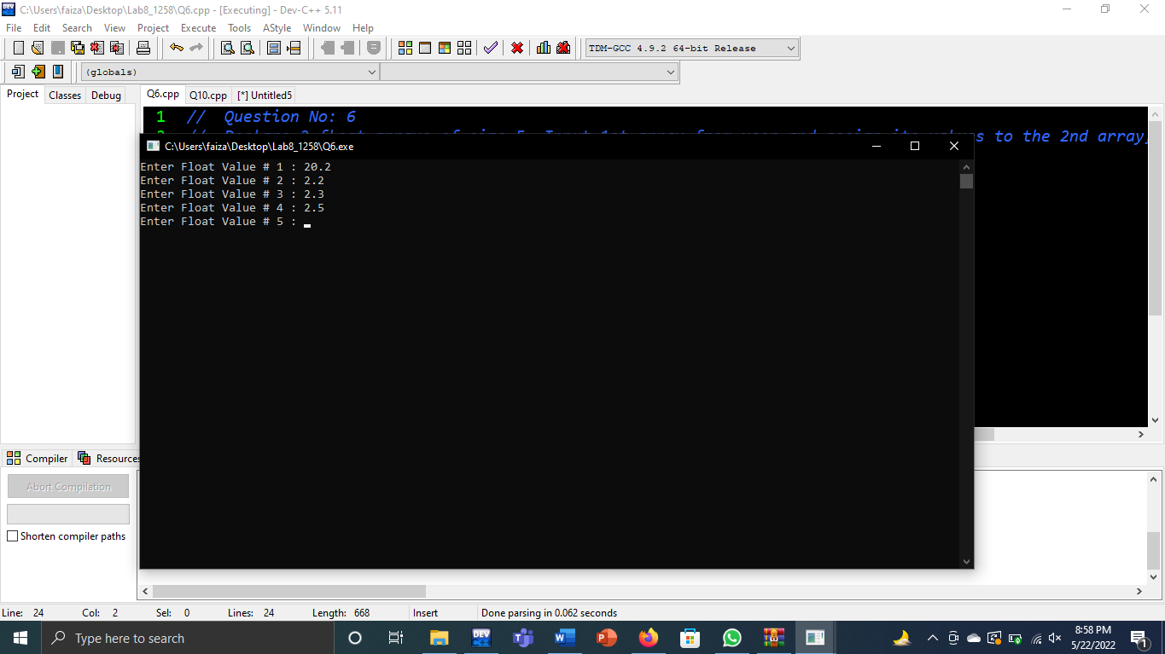

**(Q7)**

#include<iostream>

using namespace std;

int main()

{

int arr[10];

for(int i=0;i<=9;i++)

{

cout<<"Enter element # "<<i+1<<" : ";

cin>>arr[i];

}

cout<<"======================"<<endl;

for(int i=0;i<=9;i++)

{

cout<<arr[i]<<endl;

}

}

**Output**

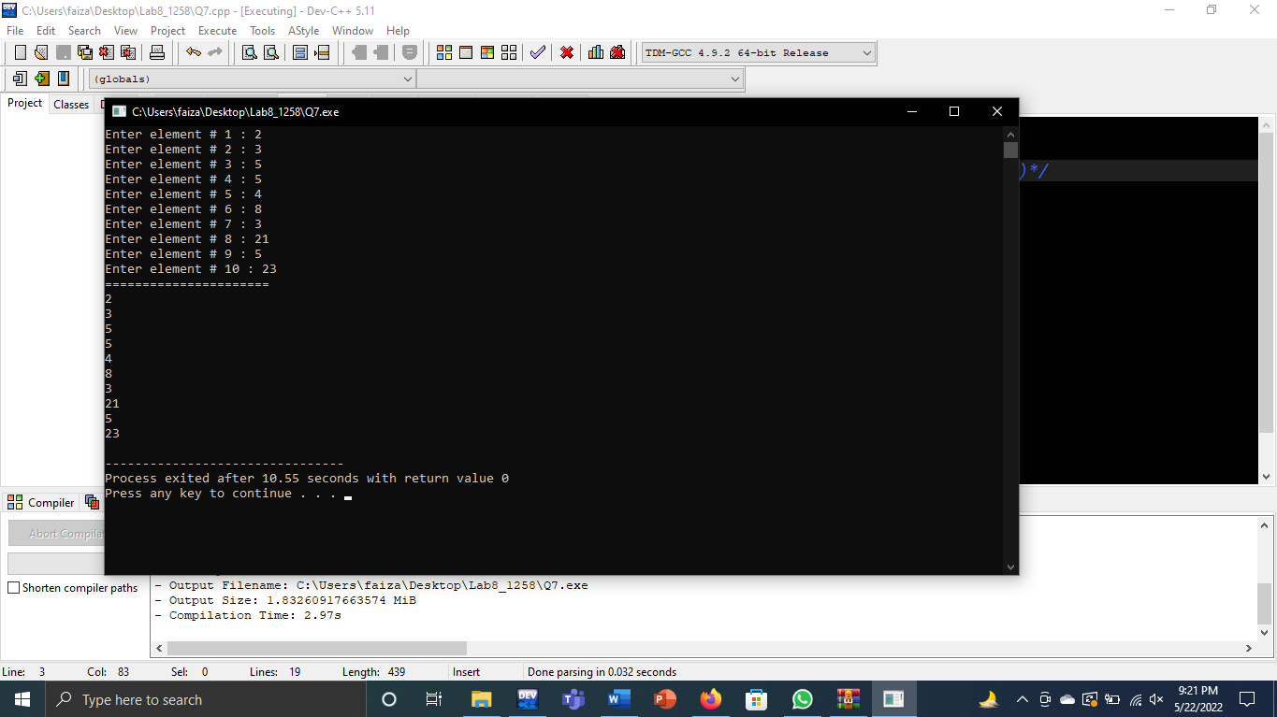

**(Q8)**

#include<iostream>

using namespace std;

int main()

{

float ar1[10],ar2[10];

for(int i=0;i<=9;i++)

{

cout<<"Enter element # "<<i+1<<" : ";

cin>>ar1[i];

}

cout<<"================="<<endl;

for(int j=0;j<=9;j++)

{

ar2[j]=ar1[j];

cout<<ar2[j]<<" ";

}

}

**Output**

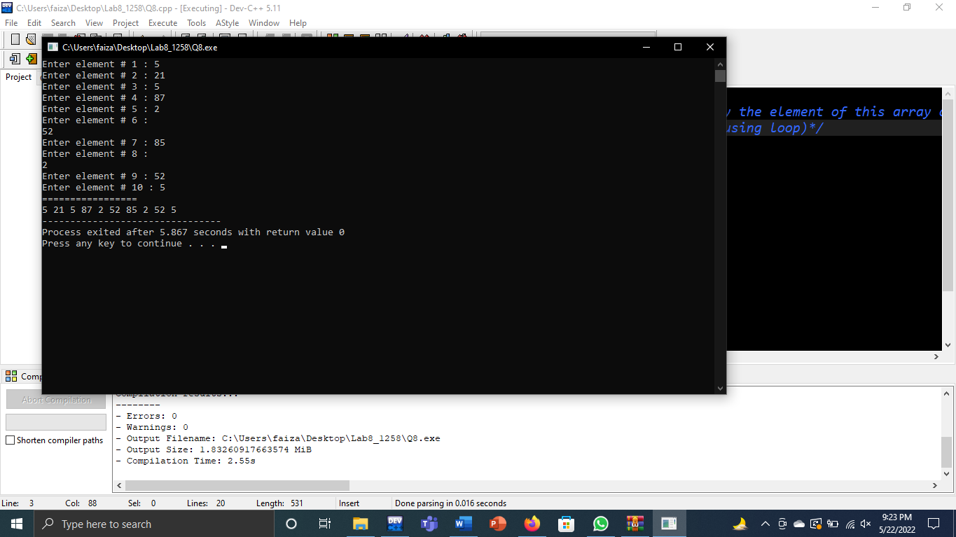

**(Q9)**

#include<iostream>

using namespace std;

int main()

{

int ar[5],temp1,temp2;

for(int i=0;i<=4;i++)

{

cout<<"Enter element # "<<i+1<<" : ";

cin>>ar[i];

}

temp1=ar[0];

ar[0]=ar[4];

ar[4]=temp1;

temp2=ar[1];

ar[1]=ar[3];

ar[3]=temp2;

cout<<"=================="<<endl;

cout<<"The elements after swapping are"<<endl;

for(int j=0;j<=4;j++)

{

cout<<ar[j]<<"\t";

}

}

**Output**

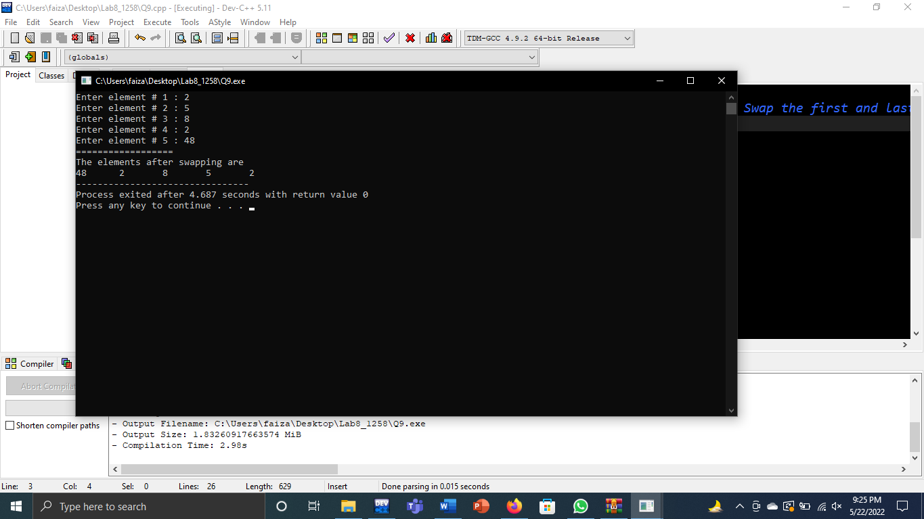

**(Q10)**

#include<iostream>

using namespace std;

int main()

{

int array[10]={0}, sum;

float avg;

for(int i=0; i<10; i++)

{

cout<<"Enter marks ";

cin>>array[i];

sum=sum+array[i];

}

avg=sum/10.0;

cout<<"The average of marks is "<<avg;

}

**Output**

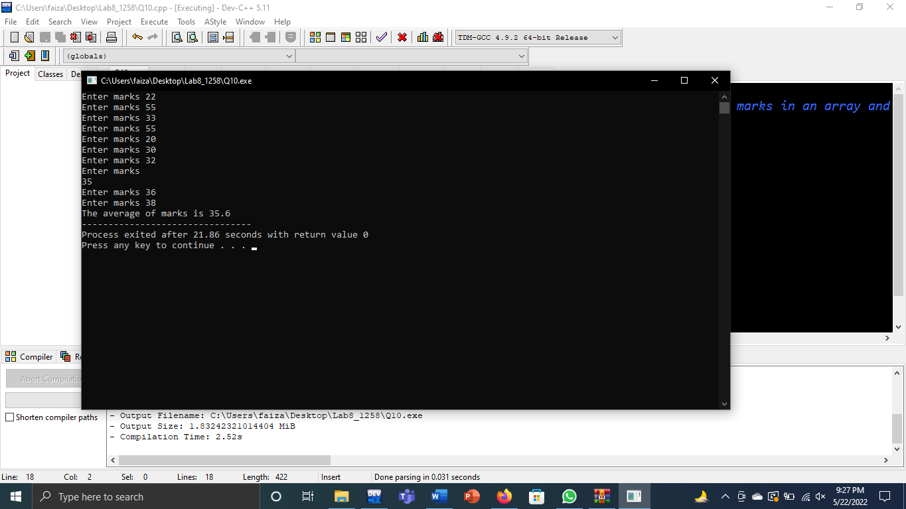

**(Q11)**

#include<iostream>

using namespace std;

int main()

{

int array[10]={0},np=0,nf=0,n=1;

for(int i=0; i<10; i++)

{

cout<<n<<" ";

n++;

cout<<"Enter marks ";

cin>>array[i];

if(array[i]>50)

np++;

if(array[i]<=50)

nf++;

}

cout<<"Number of pass student is "<<np<<endl;

cout<<"Number of fail student is "<<nf;

}

**Output**

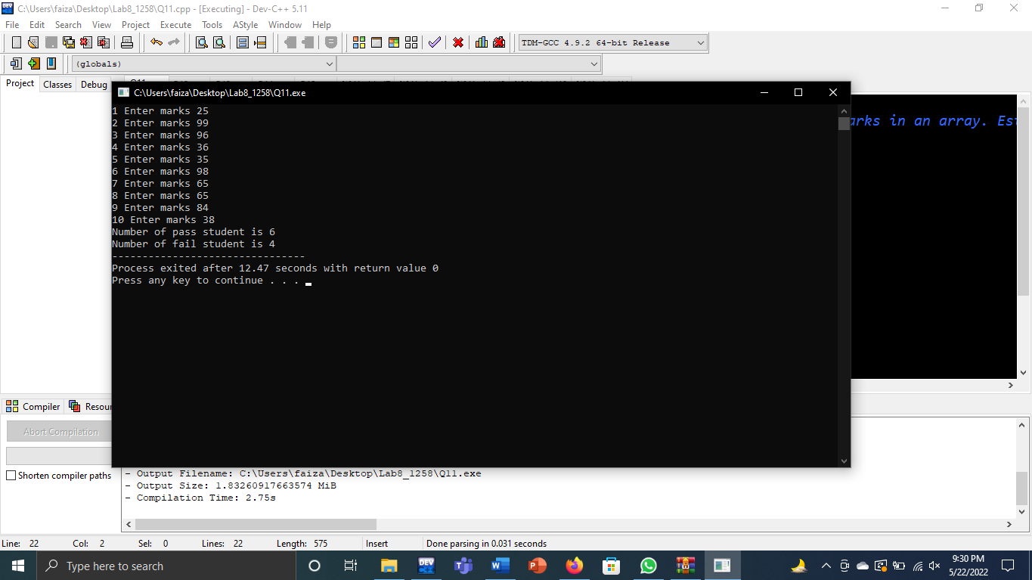

**(Q12)**

#include<iostream>

using namespace std;

int main()

{

int ar1[7]={1,2,3,4,5,6,7};

int ar2[7];

for(int i=0;i<=6;i++)

{

ar2[i]=ar1[i];

cout<<ar2[i]<<endl;

}

}

**Output**

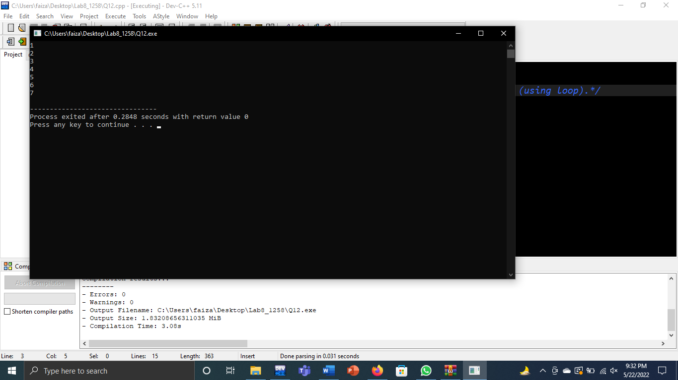

**(Q13)**

#include<iostream>

using namespace std;

int main()

{

int array[10]={0};

for(int i=0; i<10; i++)

{

cout<<"enter a number ";

cin>>array[i];

}

for(int a=0; a<10; a++)

{

if(array[a]<=20)

{

for(int b=1; b<=array[a]; b++)

cout<<"#";

cout<<"\n";

}

else

cout<<"please enter number less than or equal to 20\n";

}

}

**Output**

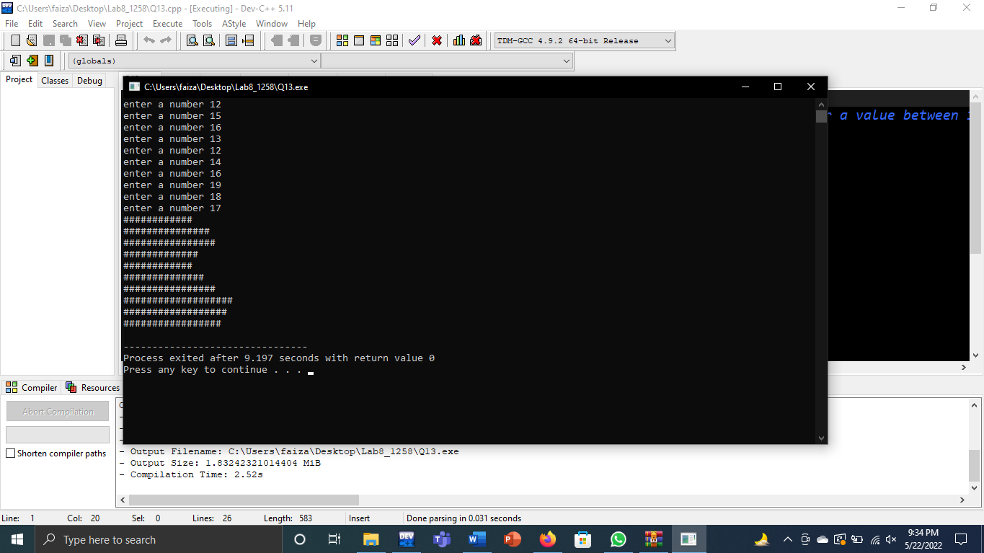

**(Q14)**

#include<iostream>

using namespace std;

int main()

{

int arr[10];

for(int i=0;i<=9;i++)

{

cout<<"Enter element # "<<i+1<<" : ";

cin>>arr[i];

}

int small=arr[0];

for(int j=0;j<=9;j++)

{

if(arr[j]<small)

{

small=arr[j];

}

}

cout<<"Smallest value is "<<small;

}

**Output**

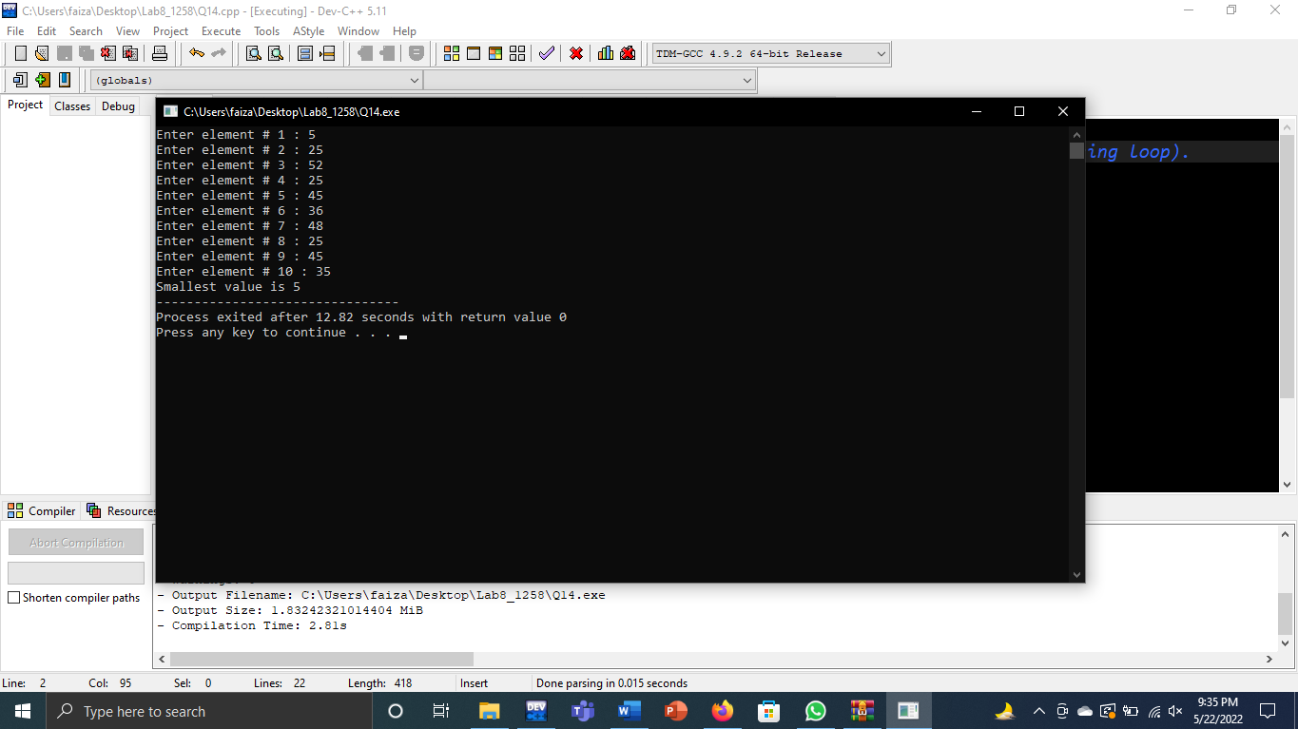

**(Q15)**

#include<iostream>

using namespace std;

int main()

{

int arr[10];

for(int i=0;i<=9;i++)

{

cout<<"Enter element # "<<i+1<<" : ";

cin>>arr[i];

}

int large=arr[0];

for(int j=0;j<=9;j++)

{

if(arr[j]>large)

{

large=arr[j];

}

}

cout<<"Largest value is "<<large;

}

**Output**

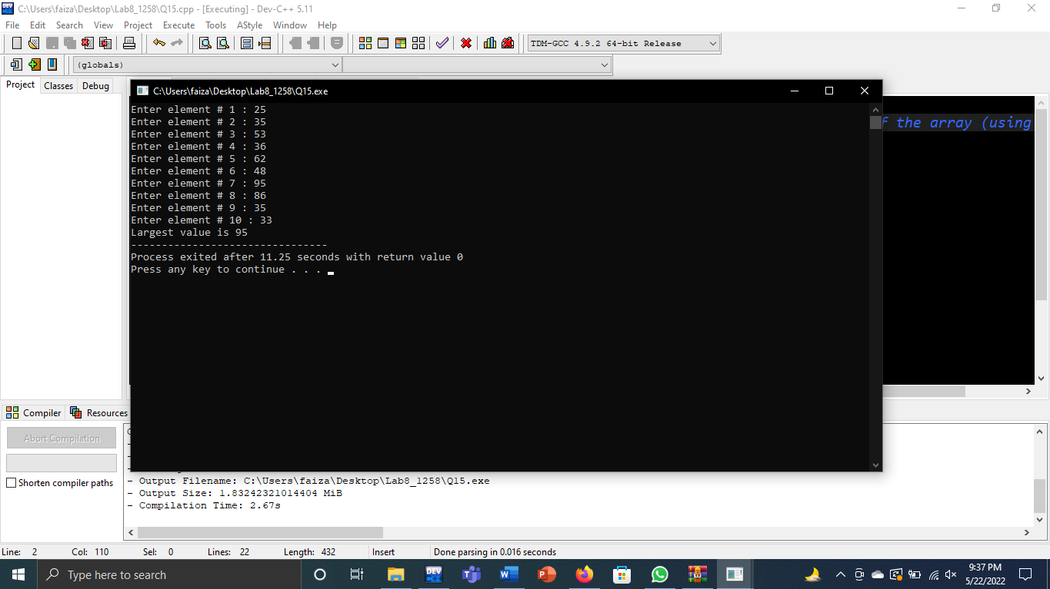

**(Q16)**

#include<iostream>

using namespace std;

int main(){

int array[20]={1,2,3,4,5,6,7,8,9,10,11,12,13,14,15,16,17,18,19,20};

int i,n,found=0;

cout<<"\n enter the values you want to search: ";

cin>>n;

for(int i=0;i<20;i++){

if(n==array[i]){

found=1;

}

}

if(found==1){

cout<<"\n---VALUE EXIST---";

}

else

cout<<"\n--VALUE DOES NOT EXIST--";

return 0;

}

**Output**

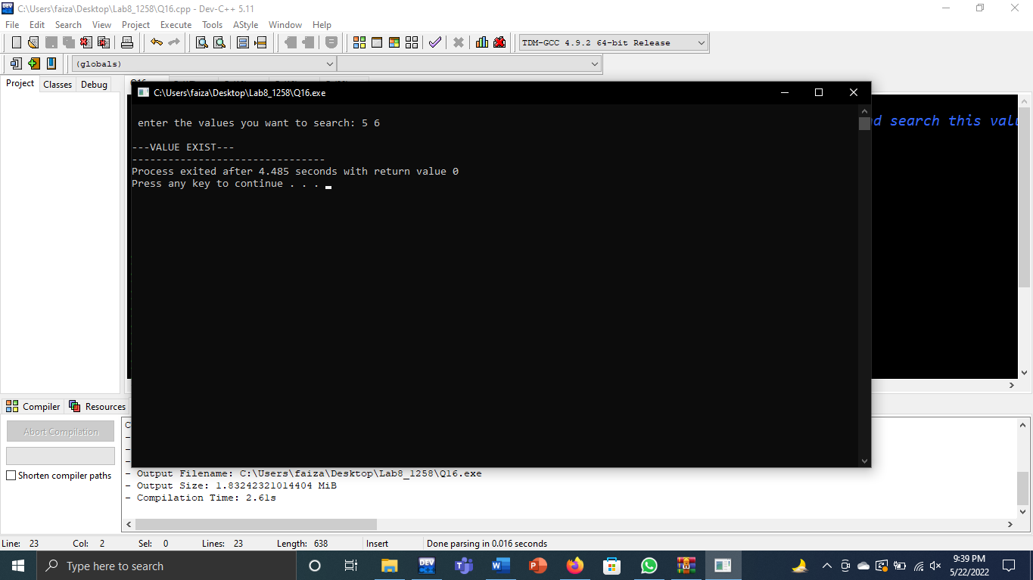

**(Q17)**

#include<iostream>

using namespace std;

int main(){

int array[10]={1,2,3,4,5,5,4,4,4,3};

int i,n,count=0;

cout<<"enter the value you want to search: ";

cin>>n;

for(int i=0;i<10;i++){

if(n==array[i]){

count=count+1;

}

}

cout<<count<<" times exist in the array";

return 0;

}

**Output**

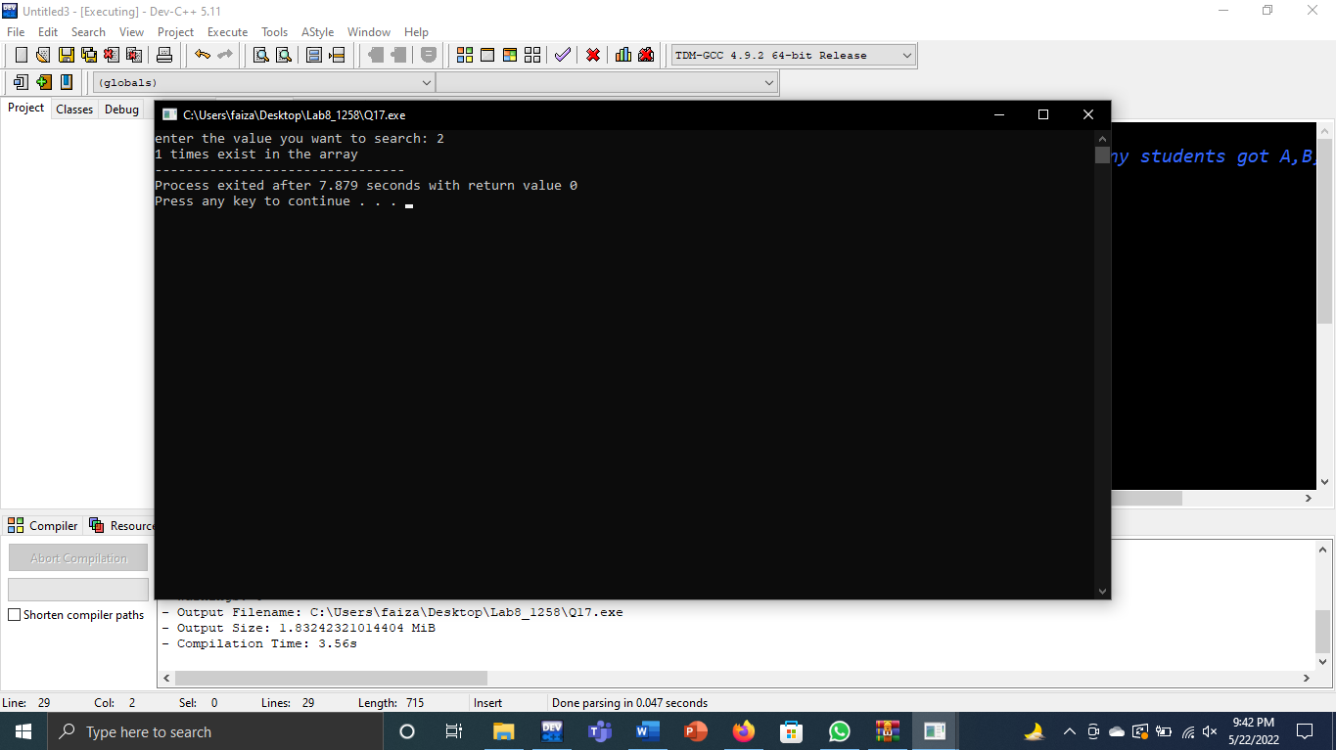

**(Q18)**

#include<iostream>

using namespace std;

int main(){

char array[10]={'A','B','C','C','F','F','A','A','F','B'};

int i,n,a=0,b=0,c=0,f=0;

for(int i=0;i<10;i++){

if(array[i]=='A'){

a=a+1;

}

if(array[i]=='B'){

b=b+1;

}

if(array[i]=='C'){

c=c+1;

}

if(array[i]=='F'){

f=f+1;

}

}

cout<<a<<" students got A grade"<<endl;

cout<<b<<" students got B grade"<<endl;

cout<<c<<" students got C grade"<<endl;

cout<<f<<" students got F grade"<<endl;

return 0;

}

**Output**

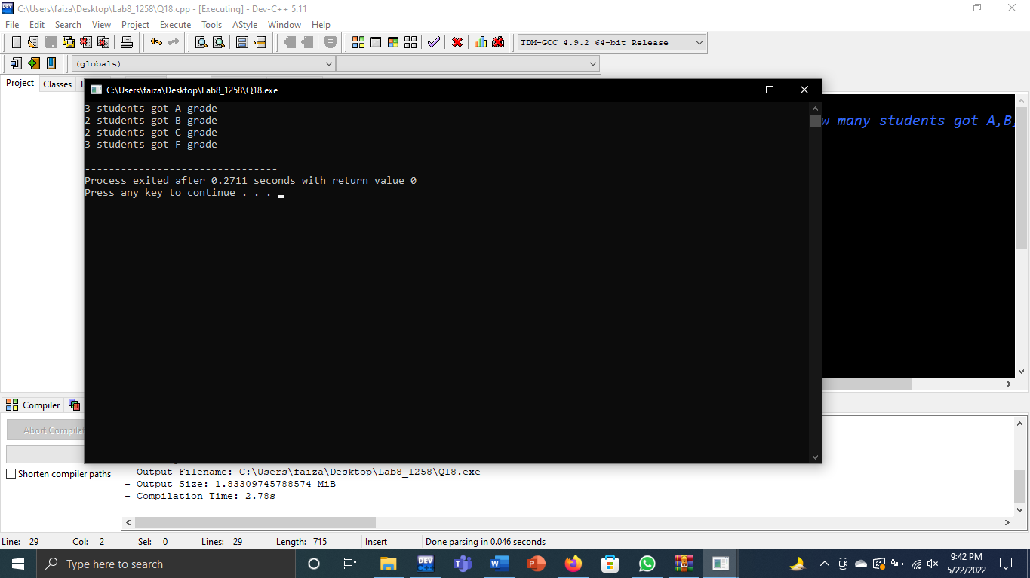

**(Q19)**

#include<iostream>

using namespace std;

int main(){

char array[10];

int n,found=0;

cout<<"enter first alphabet of your name: ";

for(int i=0;i<10;i++){

cin>>array[i];

}

for(int i=0;i<10;i++){

cout<<array[i]<<" ";

if(array[i]=='C'){

found=found+1;

}

}

cout<<endl;

cout<<found<<" no of names start with C "<<endl;

return 0;

}

**Output**

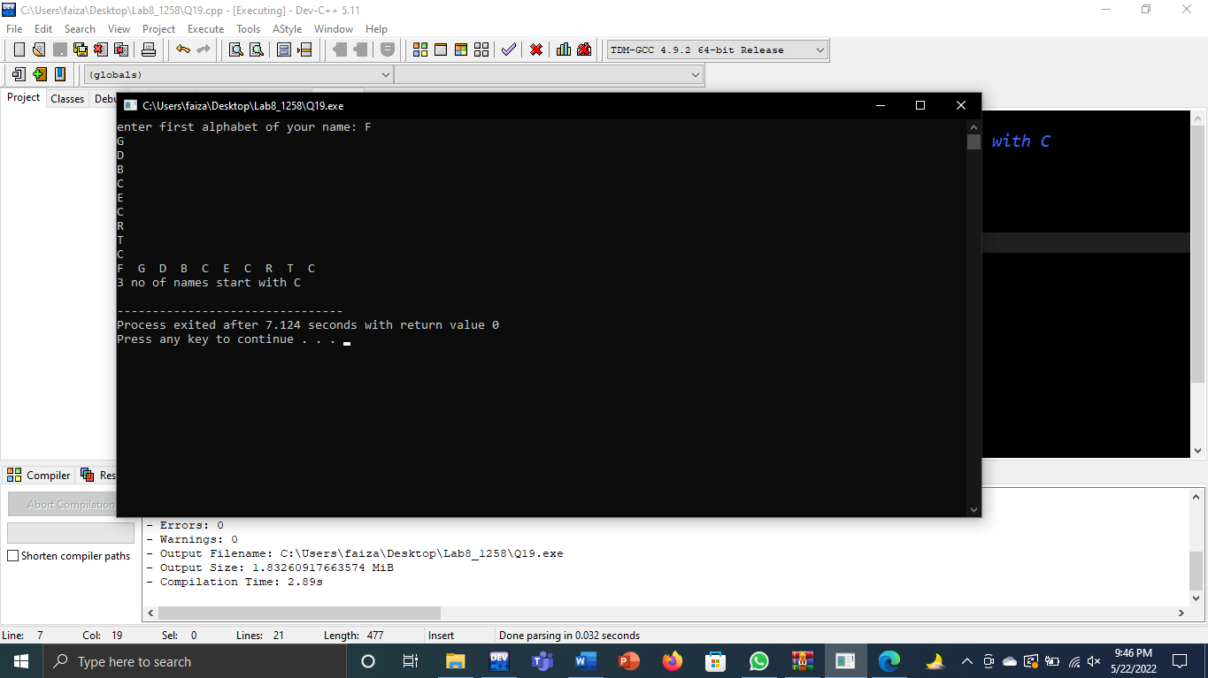

**(Q20)**

#include<iostream>

using namespace std;

int main(){

int size=10;

int array[size];

cout<<"please enter 10 numbers: ";

for(int start=0;start<size;start++){

cin>>array[start];

}

cout<<endl;

//entered numbers

cout<<"entered number "<<endl;

for(int start=0;start<size;start++){

cout<<array[start]<<" ";

}

cout<<endl<<endl;

//descending

cout<<" sorting in descending"<<endl;

for(int start=0;start<size-1;start++){

for(int start=0;start<size-1;start++){

if(array[start]<array[start+1]){

int temparray=array[start];

array[start]=array[start+1];

array[start+1]=temparray;

}

}

}

for(int start=0;start<size;start++){

cout<<array[start]<<" ";

}

cout<<endl<<endl;

//ascending

cout<<" sorting in ascending"<<endl;

for(int start=0;start<size-1;start++){

for(int start=0;start<size-1;start++){

if(array[start]>array[start+1]){

int temparray=array[start];

array[start]=array[start+1];

array[start+1];

}

}

}

for(int start=0;start<size;start++){

cout<<array[start]<<" ";

}

return 0;

}

**Output**

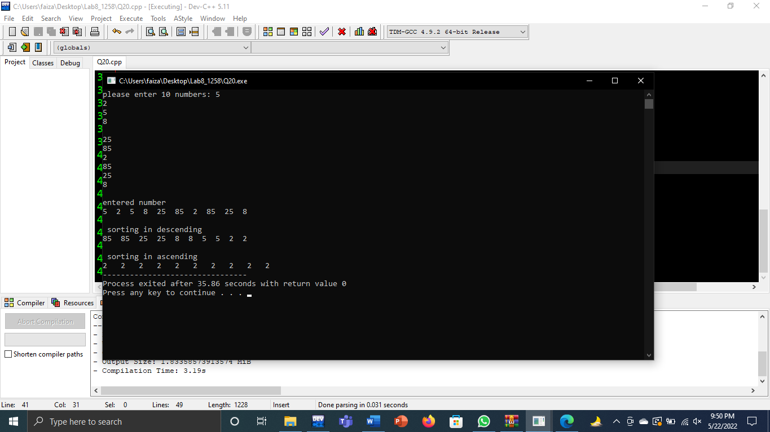

**(Q21)**

#include<iostream>

using namespace std;

int main(){

int size=10;

float array[size];

cout<<"please enter 10 numbers: ";

for(int start=0;start<size;start++){

cin>>array[start];

}

cout<<endl;

//entered numbers

cout<<"entered number "<<endl;

for(int start=0;start<size;start++){

cout<<array[start]<<" ";

}

cout<<endl<<endl;

//descending

cout<<" sorting in descending"<<endl;

for(int start=0;start<size-1;start++){

for(int start=0;start<size-1;start++){

if(array[start]<array[start+1]){

float temparray=array[start];

array[start]=array[start+1];

array[start+1]=temparray;

}

}

}

for(int start=0;start<size;start++){

cout<<array[start]<<" ";

}

cout<<endl<<endl;

//ascending

cout<<" sorting in ascending"<<endl;

for(int start=0;start<size-1;start++){

for(int start=0;start<size-1;start++){

if(array[start]>array[start+1]){

float temparray=array[start];

array[start]=array[start+1];

array[start+1]=temparray;

}

}

}

for(int start=0;start<size;start++){

cout<<array[start]<<" ";

}

return 0;

}

**Output**

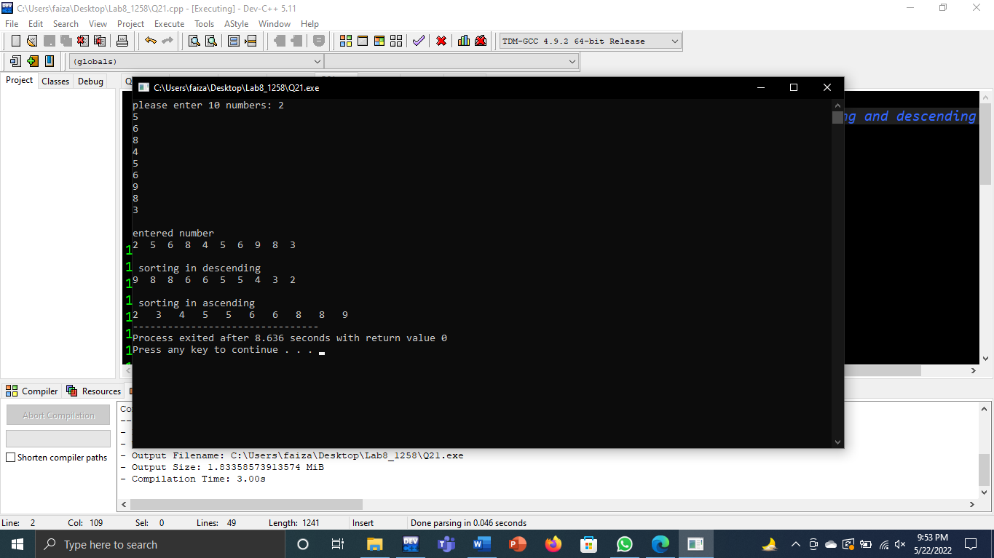

**(Q22)**

#include<iostream>

using namespace std;

int main(){

int size=10;

char array[size];

cout<<"please enter 10 numbers: ";

for(int start=0;start<size;start++){

cin>>array[start];

}

cout<<endl;

//entered numbers

cout<<"entered number "<<endl;

for(int start=0;start<size;start++){

cout<<array[start]<<" ";

}

cout<<endl<<endl;

//descending

cout<<" sorting in descending"<<endl;

for(int start=0;start<size-1;start++){

for(int start=0;start<size-1;start++){

if(array[start]<array[start+1]){

char temparray=array[start];

array[start]=array[start+1];

array[start+1]=temparray;

}

}

}

for(int start=0;start<size;start++){

cout<<array[start]<<" ";

}

cout<<endl<<endl;

//ascending

cout<<" sorting in ascending"<<endl;

for(int start=0;start<size-1;start++){

for(int start=0;start<size-1;start++){

if(array[start]>array[start+1]){

char temparray=array[start];

array[start]=array[start+1];

array[start+1]=temparray;

}

}

}

for(int start=0;start<size;start++){

cout<<array[start]<<" ";

}

return 0;

}

**Output**

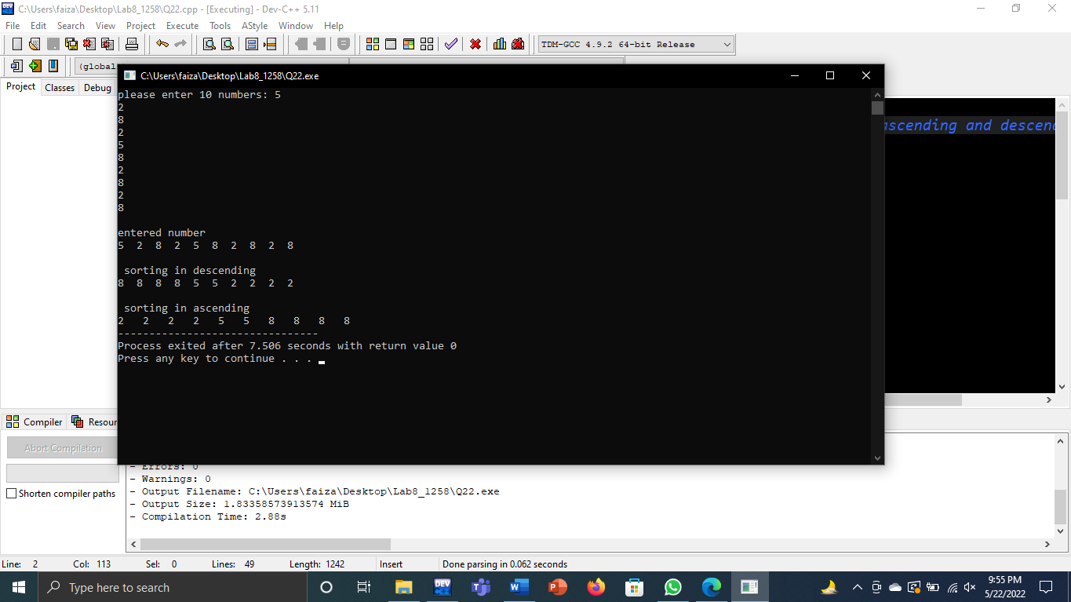

**(Q23)**

#include<iostream>

using namespace std;

int main(){

int record[5]={03,56,78,23,12};

int number1,number2;

int found1=0;

int found2=0;

cout<<"please enter first number to search: ";

cin>>number1;

cout<<"enter second number: ";

cin>>number2;

for(int start=0;start<5;start++){

if(number1==record[start]){

found1=found1+1;

}

if(number2==record[start]){

found2=found2+1;

}

}

if(found1==0&&found2==0){

found2=found2+1;

}

if(found1==0&&found2==0){

cout<<endl<<"value not exists"<<endl;

}

else{

cout<<endl<<number1<<"exists"<<found1<<"times in the record"<<endl;

cout<<endl<<number2<<" exists "<<found2<<"times in the record"<<endl;

}

return 0;

}

**Output**

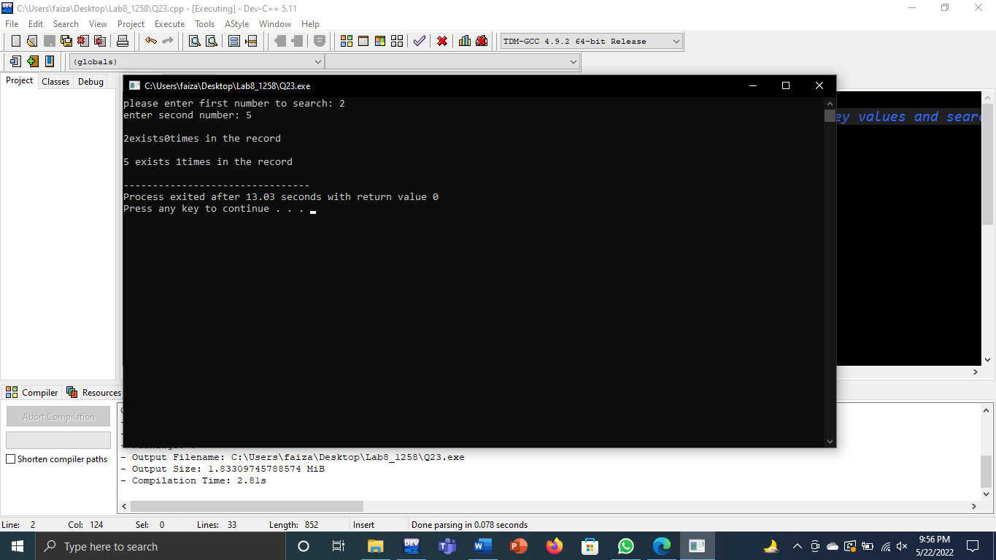

**(Q24)**

#include<iostream>

using namespace std;

int main(){

int bound;

cout<<"please enter bound: ";

cin>>bound;

int fib[100]={0};

int firstnumber,secondnumber,thirdnumber;

firstnumber=0;

secondnumber=1;

int start=0;

while(firstnumber<bound){

fib[start]=firstnumber;

thirdnumber=firstnumber+secondnumber;

firstnumber=secondnumber;

secondnumber=thirdnumber;

start++;

}

cout<<"fabonaci series is: ";

for(int start=0;start<=100;start++){

if(fib[start]==0&&start!=0){

break;

}

cout<<" "<<fib[start];

}

return 0;

}

**Output**

